COMMON COURSE ASSIGNMENT

Varshini(192472358)

S.Siva Archana(192511128)

Assignment Information

Particular | Details
Department: | CSE-AI
Course Code & Course Name | DSA0101 and Object Oriented Programming with C++
Academic Year / Batch | 3rd
Faculty Name | Dr.M.Gunasekaran
Assignment Title | Smart Civic Complaint and Public Safety Response System using C++
Date of Issue | 02-09-2026
Date of Submission | 03-09-2026
Maximum Marks | 100
Course Outcome(s) – CO | CO2: Design C++ programs by applying functions and object-oriented concepts such as classes, objects, access specifiers, member functions, static members, and arrays of objects to solve real-world programming problems.  CO3: Construct C++ programs using constructors, destructors, and operator overloading mechanisms to control object creation, destruction, and operator behaviour.  CO4: Analyse and implement C++ applications using inheritance, types of inheritance, virtual base classes, abstract classes, pointers, and polymorphism to design reusable and extensible programs.
Bloom's Taxonomy Level | L3 – Apply; L4 – Analyse
SDG Mapping (SDG 1-17) | SDG 9 – Industry, Innovation and Infrastructure; SDG 11 – Sustainable Cities and Communities; SDG 16 – Peace, Justice and Strong Institutions

Assignment Problem / Challenge
Faculty shall provide a realistic engineering/scientific/computing problem, case, challenge or design requirement related to the Course Outcome.
The assignment should preferably require students to:

  - Apply course concepts rather than reproduce theory.
  - Identify and analyze the problem.
  - Consider requirements and constraints.
  - Develop or compare alternative solutions where appropriate.
  - Use relevant modern engineering/computing/design tool
● Make and justify engineering decisions.
● Consider appropriate technical, economic, environmental, societal, ethical, safety or
sustainability factors wherever relevant.

Problem Statement

Problem / Case / Design Challenge:

[Faculty to provide the detailed assignment problem here.]

Requirements and Constraints
Students shall identify or be provided with relevant requirements and constraints. Examples include:
  - Functional requirements
  - Performance requirements
  - Technical constraints
  - Cost, Time
  - Resources
  - Safety
  - Reliability
  - Sustainability
  - Environmental and Ethical considerations
  - Standards/codes
  - User requirements
  - Manufacturability
  - Power/energy
  - Security/privacy

Only constraints relevant to the particular course/problem need to be considered.

Student Work

Problem Understanding and Formulation
The main problem is the inefficient handling of civic complaints and public-safety issues. A complaint management system should not only store complaints but also identify urgent cases and ensure that they receive faster attention.
The proposed system divides complaints into categories such as:
- Road and Infrastructure
- Garbage and Sanitation
- Streetlight
- Water Supply
- Traffic
- Public Safety
- Other Civic Issues
Priority can be assigned as:
Priority | Description
Critical | Immediate public-safety risk
High | Requires quick response
Medium | Normal civic issue
Low | Non-urgent complaint
The expected outcome is a structured system that helps administrators identify urgent complaints and manage the overall complaint lifecycle.

Application of Course Knowledge
The system applies the following C++ concepts:

C++ Concept | Application in Project
Classes and Objects | Represent citizens, complaints and response personnel
Structures | Store complaint information
Functions | Perform individual system operations
Vectors | Store multiple complaint records
Priority Queue | Manage urgent complaints
Searching | Find complaints using ID/category
Sorting | Arrange complaints by priority/date
File Handling | Save and retrieve complaint records

Solution / Design / Methodology

System Workflow

Citizen
↓
Register Complaint
↓
Enter Complaint Details
↓
Categorize Complaint
↓
Assign Priority
↓
Store Complaint
↓
Priority Queue
↓
Assign Response
↓
Update Status
↓
Resolve Complaint
↓
Generate ReportData analysis
Where appropriate, consider more than one possible solution.
Pseudo code:
BEGIN

CREATE array of Citizen objects
CREATE array of Complaint objects
CREATE array of Response Team objects

INITIALIZE citizen count = 0
INITIALIZE complaint count = 0

DISPLAY "SMART CIVIC COMPLAINT AND PUBLIC SAFETY RESPONSE SYSTEM"

REPEAT

DISPLAY MAIN MENU

1. Register Citizen
2. Register Complaint
3. Display Complaints
4. Calculate Complaint Priority
5. Assign Response Team
6. Update Complaint Status
7. Compare Complaints
8. Display Team Workload
9. Generate Civic Response Report
10. Exit

READ choice

IF choice = 1 THEN

READ citizen ID
READ citizen name
READ contact number

CREATE Citizen object
STORE citizen details in Citizen array

INCREMENT citizen count

DISPLAY "Citizen registered successfully"

ELSE IF choice = 2 THEN

READ complaint ID
READ citizen ID
READ complaint type
READ complaint description
READ urgency level

CREATE Complaint object

CLASSIFY complaint according to complaint type

CALCULATE priority score

STORE complaint in Complaint array

INCREMENT complaint count

DISPLAY "Complaint registered successfully"

ELSE IF choice = 3 THEN

IF complaint count = 0 THEN
DISPLAY "No complaints available"
ELSE
FOR each complaint in Complaint array
DISPLAY complaint details
END FOR
END IF

ELSE IF choice = 4 THEN

READ complaint ID

SEARCH for complaint using complaint ID

IF complaint is found THEN

CALCULATE priority score
DISPLAY priority score

ELSE
DISPLAY "Complaint not found"

END IF

ELSE IF choice = 5 THEN

READ complaint ID

SEARCH for the complaint

IF complaint is found THEN

CHECK complaint type

IF type = "Pothole" THEN
SELECT Road Maintenance Team

ELSE IF type = "Streetlight" THEN
SELECT Electrical Team

ELSE IF type = "Garbage" THEN
SELECT Sanitation Team

ELSE IF type = "Water" THEN
SELECT Water Team

ELSE IF type = "Safety" THEN
SELECT Public Safety Team

END IF

ASSIGN selected team to complaint

INCREASE team workload

USE base-class pointer to call team handling function

DISPLAY "Response team assigned successfully"

ELSE
DISPLAY "Complaint not found"

END IF

ELSE IF choice = 6 THEN

READ complaint ID
READ new status

SEARCH for complaint

IF complaint is found THEN

UPDATE complaint status

DISPLAY "Complaint status updated"

ELSE
DISPLAY "Complaint not found"

END IF

ELSE IF choice = 7 THEN

READ first complaint
READ second complaint

COMPARE priority scores using overloaded operator

IF first complaint has higher priority THEN
DISPLAY "First complaint has higher priority"
ELSE
DISPLAY "Second complaint has higher or equal priority"
END IF

ELSE IF choice = 8 THEN

DISPLAY response team information

FOR each response team
DISPLAY team name
DISPLAY current workload
END FOR

ELSE IF choice = 9 THEN

DISPLAY "CIVIC RESPONSE REPORT"

DISPLAY total number of complaints

FOR each complaint
DISPLAY complaint ID
DISPLAY complaint type
DISPLAY priority score
DISPLAY assigned team
DISPLAY current status
END FOR

DISPLAY response team workload

ELSE IF choice = 10 THEN

DISPLAY "Exiting the system"

ELSE

DISPLAY "Invalid choice"

END IF

UNTIL choice = 10

DISPLAY "System terminated successfully"

END

Complaint Processing
When a complaint is registered, the system generates a unique complaint ID. The complaint is then categorized and assigned a priority level.
Critical and high-priority complaints are placed ahead of normal complaints using a priority queue. This ensures that public-safety issues can be processed before less urgent civic problems.
The complaint status is updated throughout its lifecycle:
Pending → In Progress → Resolved

Use of Modern Tools
The implementation uses:
- C++ – Core programming language.
- Visual Studio Code / Code::Blocks – Development environment.
- G++ / MinGW – C++ compiler.
- STL – Vector, priority queue, sorting and searching.
- File handling – Persistent complaint storage.
- Git/GitHub – Version control, if applicable.

Results and Validation
The system can be validated using test cases such as:
Test Case | Input | Expected Output
1 | Add road complaint | Complaint successfully registered
2 | Add public-safety complaint | High/Critical priority assigned
3 | Search valid complaint ID | Correct complaint displayed
4 | Search invalid ID | Complaint not found
5 | Sort complaints | Complaints arranged by priority
6 | Update complaint | Status changed successfully
7 | Resolve complaint | Complaint marked as Resolved
8 | Display pending complaints | Only pending complaints displayed
9 | Multiple urgent complaints | Highest-priority complaint processed first
Implementation:
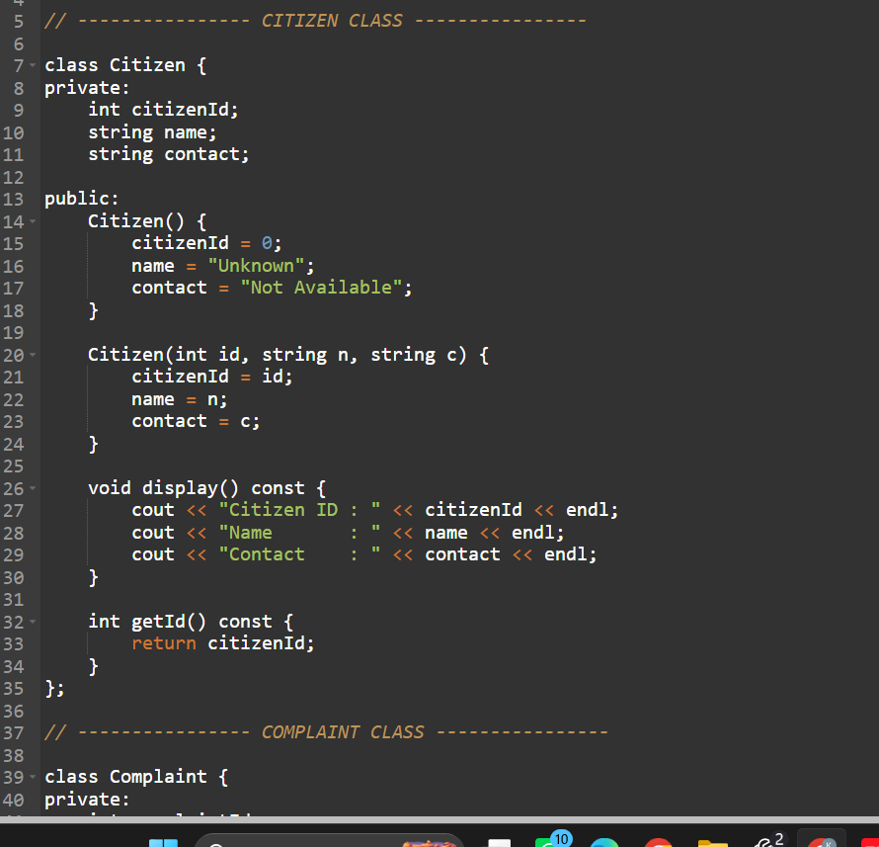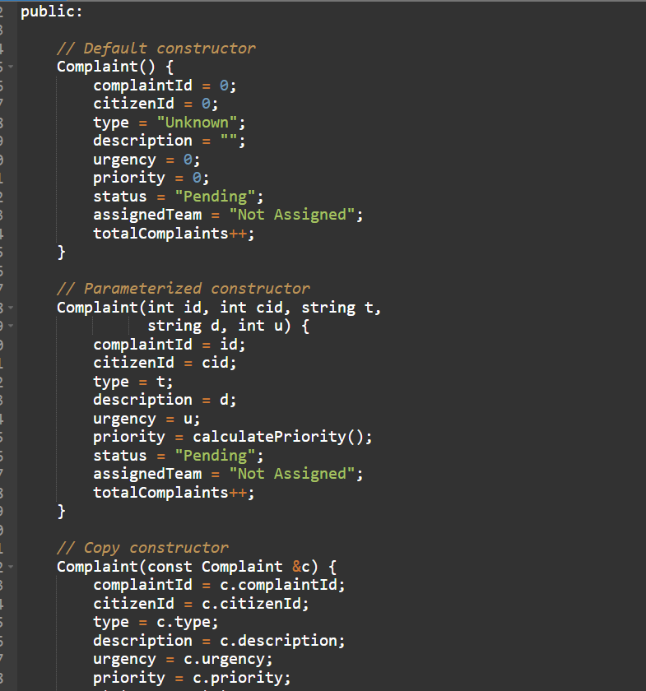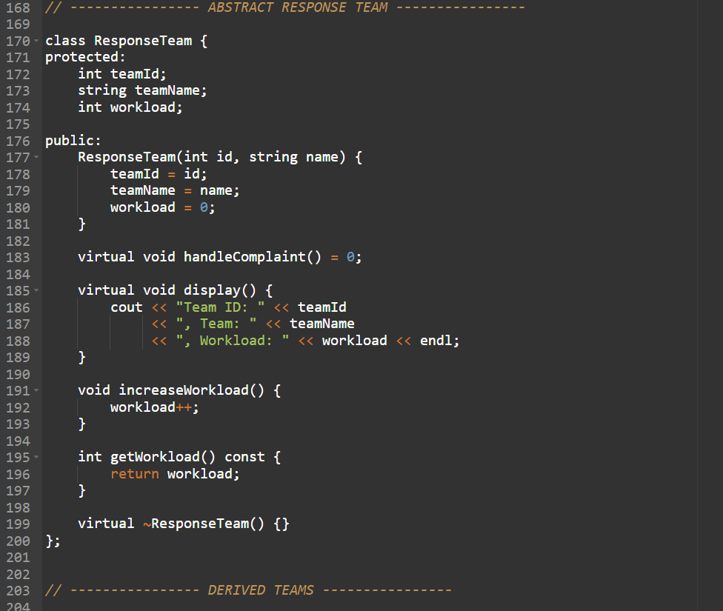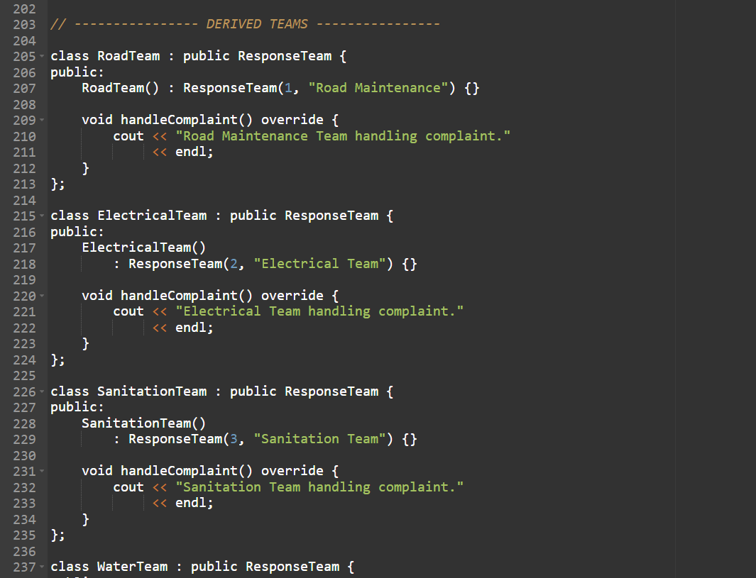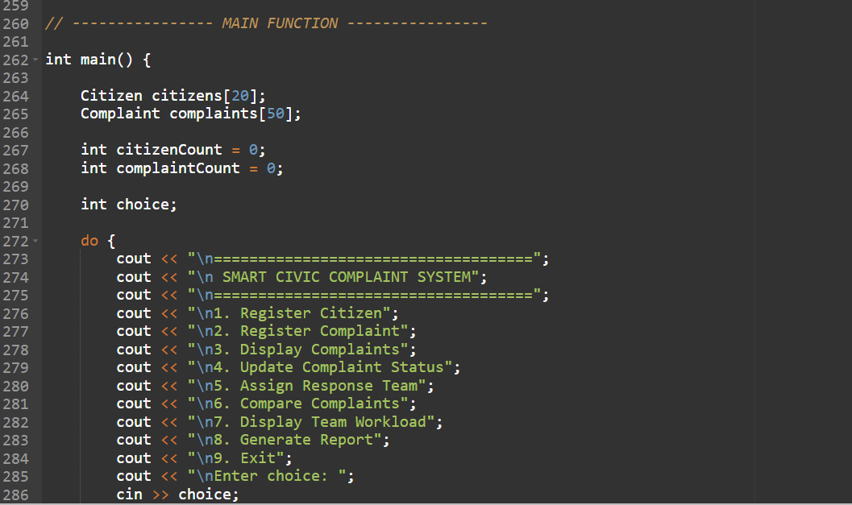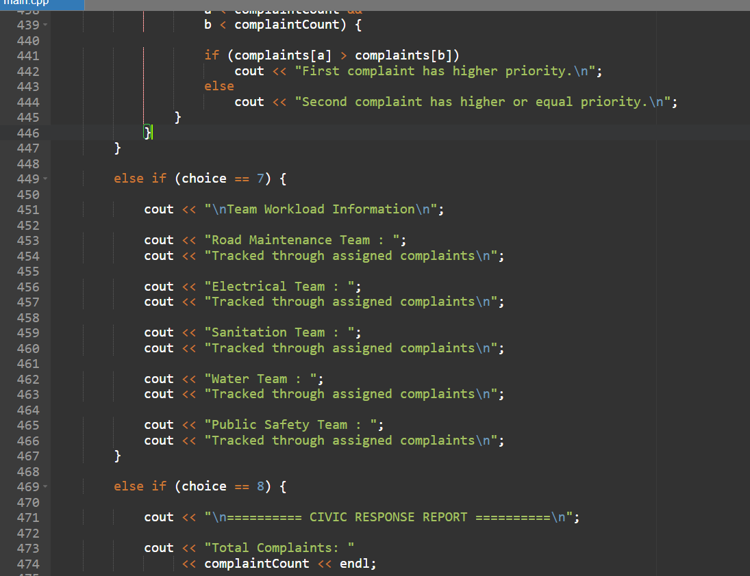

Output: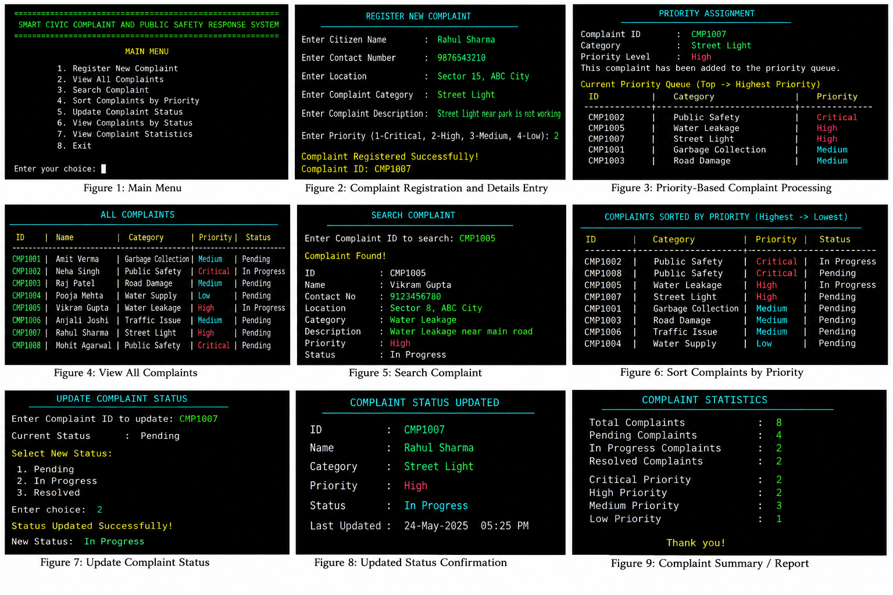

Expected Result
The system should correctly register complaints, prioritize urgent cases, retrieve records, update statuses, and maintain complaint information without data loss.

Analysis and Engineering Decision

A simple first-come-first-served queue can process complaints in the order they arrive, but it may cause critical safety complaints to wait behind less important issues.
Therefore, a priority queue is selected for complaint processing.
Approach | Advantage | Limitation
Normal Queue | Simple and fair order | Urgent complaints may be delayed
Priority Queue | Critical complaints receive faster attention | Requires priority management
Linear Search | Easy to implement | Slower for large datasets
Sorting + Search | Better organization | Additional processing required

The priority queue is selected because public-safety complaints require faster response than routine complaints.

Broader Considerations

Social Impact
The system can improve the organization of civic complaints and help authorities identify important public issues.

Safety
Critical complaints can be given higher priority, helping reduce delays in responding to potential public-safety risks.

Accessibility
A future graphical or web-based interface can make the system easier for citizens to use.

Privacy
Personal information associated with complaints should be protected and accessible only to authorized users.

Sustainability
A digital complaint system can reduce dependence on paper-based complaint records.

Conclusion
The Smart Civic Complaint and Public Safety Response System using C++ provides an organized approach for managing civic complaints. The system applies C++ programming concepts such as object-oriented programming, vectors, priority queues, searching, sorting, and file handling.
The priority-based processing mechanism helps identify urgent public-safety complaints and ensures that they receive appropriate attention. The proposed system demonstrates how fundamental programming and data-structure concepts can be applied to a practical societal problem.

Student Reflection
Through this assignment, I learned how C++ programming concepts can be combined to solve a practical problem. I gained experience in designing classes, managing collections of records, using priority queues, implementing searching and sorting, and storing data using file handling.
If additional time and resources were available, I would improve the system by developing a GUI/web interface, database connectivity, real-time complaint tracking, location-based complaint mapping, notification services, and administrator authentication.

References

- Bjarne Stroustrup, The C++ Programming Language, Addison-Wesley.
- Stanley B. Lippman, Josée Lajoie and Barbara E. Moo, C++ Primer, Addison-Wesley.
- ISO/IEC 14882, Programming Languages – C++.
- C++ Standard Template Library documentation.
- OpenStreetMap documentation, for possible future location-based complaint mapping.
- Microsoft Visual Studio Code documentation, for development environment reference.

Common Assessment Rubric

Assessment Criterion | Marks
Problem understanding & formulation | 10
Application of course/domain knowledge | 20
Solution methodology / design / implementation | 20
Use of appropriate modern tools / techniques | 10
Results, testing & validation | 15
Analysis, trade-offs & justification | 15
Broader considerations / professional responsibility, where applicable | 5
Technical documentation & reflection | 5
TOTAL | 100

CO–PO–Assessment Mapping

Assessment Component | CO | PO(s) | Bloom's Level | Marks
Problem formulation |  |  | L3/L4 | 10
Application of knowledge |  |  | L3/L4 | 20
Solution / Design / Implementation |  |  | L4/L5/L6 | 20
Modern tool usage |  |  | L3/L4 | 10
Validation |  |  | L4/L5 | 15
Analysis & justification |  |  | L4/L5 | 15
Broader considerations |  |  | L4/L5 | 5
Documentation & reflection |  |  | L3/L4 | 5
Note: Faculty shall map only the POs and Bloom's levels genuinely assessed by the particular assignment. Every assignment is not required to map to every PO.

Faculty Evaluation & Continuous Improvement CO Attainment

Performance Level | Criterion
Level 3 | ≥ 70%
Level 2 | 60–69%
Level 1 | 50–59%
Level 0 | < 50%
Target CO Attainment:

Actual CO Attainment:

Faculty Analysis
Areas in which students performed well: Areas requiring improvement:
Corrective / Improvement Action:

Action to be implemented in the next offering:

Documents to be Maintained

The department/course faculty shall maintain:

- Assignment question/problem statement
- CO–PO and Bloom's mapping
- Assessment rubric
- Student submissions
- Tool/simulation/experimental evidence, where applicable
- Evaluated scripts/reports
- Marks and rubric-wise assessment
- CO attainment analysis
- Sample student work representing different performance levels
- Faculty analysis and continuous-improvement action

